De La Salle Santiago Zobel School
HIGH SCHOOL DEPARTMENT
2nd Term, AY 2014-2015

UNIT ASSESSMENT MATRIX (with Table of Specifications)

Subject: | ART |  |  |  | LEVEL: | G7 |  | TEACHER: | Ms. Rikka Marie S. Gonzalez
ASSESSMENTS: |  |  | Online quiz, task sheets, and final output

Learning Module: |  | Art Techniques
Content Standard: |  | - Art Technique
Performance Standard: |  | - Drawing from observation  - Conceptualize and sketch three dimensional subjects with various art techniques  - Develop final artwork (self-portrait) using various Art Techniques  - Share and convey thoughts through writing an Art Journal which contains ideas, development, and opinion regarding the topics discussed and what the students learned throughout the term.
UNIT CONTENT: |  | - Art Techniques | - Value and Tone, Hatching, Scumbling and Stippling |  | - Vertical, Horizontal, Diagonal and Cross Hatching

What will I assess? |  | How will I assess? |  | How will I score?
KNOWLEDGE | 15% | Test Items  (Please indicate the type of assessment: S-Short Assessment, L-Long Assessment, etc.) | Type | Item Nos. | Scoring  (3 Point Per Item)
Learning Competency
- To identify art techniques used in sketching and drawing |  | Short Assessment  Direction: Identify the drawing technique applied in each drawing. Write the correct answer on the space provided.  - 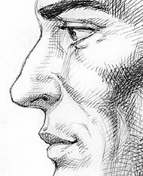 ______________________________  - 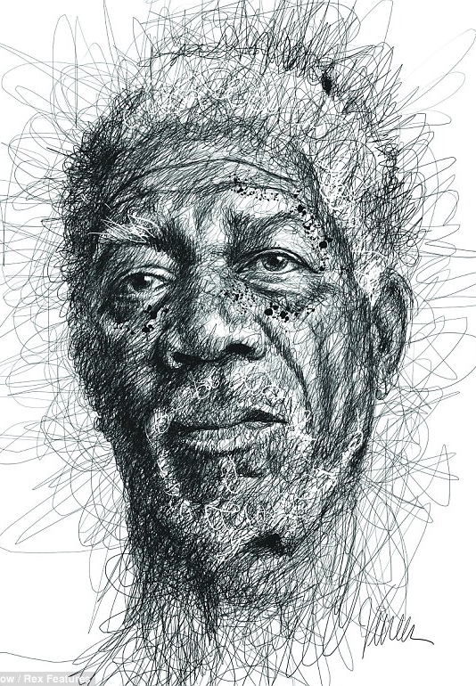 _____________________________  - 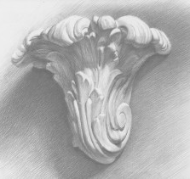 _____________________________  - 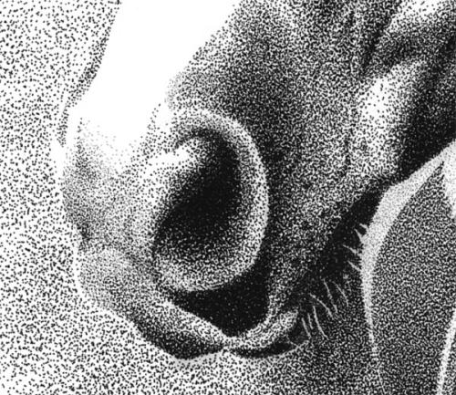 ________________________  - 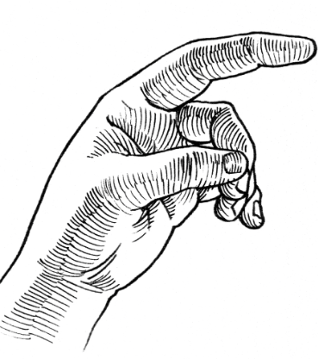 _________________________ | S | 5 | X(3)  Total Points: 15 Points
 |  | Total No. of Items/Total Score: |  | 15
PROCESS | 25% | Test Items  (Please indicate the type of assessment: S-Short Assessment, L-Long Assessment, ET-End-Term Assessment, etc.) | Type | Item Nos. | Holistic Rubric Scoring Guide  (10 Points Per Plate)
Learning Competency
- To visually recognize art techniques applied in artworks  - To draw concept sketches of figures/forms |  | Long Assessment  As a developing artist, you were tasked to create several outputs which illustrates the application of pencil drawing teachniques such as the following:  - Hatching (Vertical, Horizontal and Diagonal)  - Cross Hatching  - Scumbling  - Stippling (Subject: Flower) | L | 3 | X(5)  Total Score: 15
 |  | Rubric as manifested by the product |  |  | Excellent (5)  The student has successfully derived several methods on his own and utilized several visual elements and design principles to create the activity  Very Good (4)  The student has successfully derived a few methods on his own and utilized a few visual elements and design principles to create the activity  Acceptable (3)  The student has successfully derived two different ways on his own and utilized some visual elements and design principles to create the activity  Developing (2)  The student has successfully derived at a method and utilized very limited visual elements and design principles to create the activity  Beginning (1)  The student has yet to develop his own method and should integrate more visual elements and design principles to create the activity
 |  | Total No. of Items/Total Score: |  | 25
UNDERSTANDING | 30% | Test Items  (Please indicate the type of assessment: S-Short Assessment, L-Long Assessment, ET-End-Term Assessment, etc.) | Type | Item Nos. | Holistic Rubric Scoring Guide  (4 Points Per Item)
Essential Question,
Enduring Understanding
& Facets of Understanding
EQ:  - What is the importance of choosing particular tools, techniques, and materials in expressing an idea to an artwork? |  | Short-Term Assessment:  (Essay)  Explain the importance of choosing particular tools, techniques and materials in expressing an idea to an artwork. | S | 20 | 20 Points
EU:  - Students will understand that choosing the right art medium, and technique determine the quality of work. |  | End-Term Assessment  (Essay)  How does the application and use of proper medium and technique determine the quality of work? | ET | 10 | 10 Points
 |  | Total No. of Items/Total Score: |  | 30
PERFORMANCE | 30% | Performance Task  (in G-R-A-S-P-S Narrative Form)  As a developing artist, you are commissioned by the Art Teacher to create a portrait. This project aims to showcase the student’s ability to integrate pencil drawing techniques such as hatching, stippling, blending, and/or scribbling, to form a figure.  Using the internet as a source/reference, look for pictures of celebrities or any icon which you prefer to use a subject, and create the portrait using the grid technique. Each student will be given two weeks to work on the mentioned project.  This project will be submitted and approved by the Art Teacher. |  | Exceptional (4)  The product manifests all the necessary skills and understanding behind the given project  Acceptable (3)  The product manifest most of the necessary skills and understanding behind the given project  Developing (2)  The product manifests some of the necessary skills and understanding behind the given project  Beginning (1)  The product has to manifest the necessary skills and understanding behind the given project
Transfer Goal:

- Create, make and present artworks integrated with techniques wherein students showcased their ability to manipulate these to form a portrait using the grid method.

 |  | Total Score: |  | 30
 |  | TOTAL |  | 100

Prepared by:
Gonzalez, Rikka Marie Siwa
Grade 7 & 8 Art Teacher
09/03/14

