LASALLIAN LEARNING MODULE
Teacher: Ms. Rikka Marie S. Gonzalez | Year/Level: Grade 07 |  | Subject: Art
Term Module: 03 | Title: Historical and Cultural Aspects of Art |  | Time Frame: January-March
CONTENT STANDARD |  | PERFORMANCE STANDARD
The students demonstrate understanding that Art determines cultural oneness by providing a nation with an aesthetic ideal which forms its collective soul.  Elements and principles of design; aesthetic expression; art styles; art movements; freehand drawing; art vocabulary |  | The students will:  - Apply strategies to reflect on and respond to their own or others’ expressive work (poster)  - Create images that incorporate the styles of artists from a variety of social, historical, cultural contexts  - Create images for specific purposes (i.e. social commentary, social analysis, entertainment)
RELATED LASALLIAN GUIDING PRINCIPLES
Lasallian educational experiences are dynamic processes that:
- Challenge pupils to realize their full potential by encouraging them to exercise their creativity for the good of all, especially for those who needs more motivation;
- Bring Christian perspectives to bear on human understanding skills and values of the pupils by engaging them to address inspirational concerns of the emotionally-challenged children;
- Are vigorous and encourage differentiation, diversity and synergy amongst others that are friendly, caring and respectful by encouraging them to share their constructive criticism on various ideas for a color scramble that would promote visual thoughts and communication that could potentially inspire other people to see beauty beyond repeating design;
- Ensure that students translate knowledge into something useful in actual practice for the betterment of society and the Church by sharpening their sensitivity toward the needs of the environment by creatively utilizing visual elements and design principles on a color scramble
CONTENT and COMPETENCIES
Module 01 focuses mainly on historical and cultural aspects of art, different art styles and/or art movements.. It strengthens prior knowledge of art techniques and hone skills while affirming and deepening further the understanding of art history, several art movements and styles related to human art form and the goodness of God’s creations.
This learning area shall include exploratory, experiential and reflective activities that will enable the students to develop an appreciation for art as an expression of culture and human experiences. Activities shall include creating illustrations and/or images that incorporates variety of styles from historical, cultural and social contexts and creating illustrations and/or images for specific purposes. Skills to enhance: Freehand drawing, Art Vocabulary.
REFERENCES/ SOURCES
Bibliography

Kemper, M.L. Contemporary Drawing as Idea and Process. 2013.

Fyfe, G. Aspects of the Culture of Copies. Keele University. 2004

Webliography

www.artmovements.co.uk
www. artyfactory.com
www.artcyclopedia.com
http://d2aohiyo3d3idm.cloudfront.net/publications/virtuallibrary/0892362006.pdf
http://press.princeton.edu/chapters/s9315.pdf
http://edhelper.com/art_styles.htm

BLENDED TOOLS
Face-to-Face |  | eLearning
Examples:  Group/ pair discussions  Lab works  Coaching  Reflective Study |  | Examples:  Web research  Simulations  Online forums  Use of apps (e.g., productivity, assessment, presentation)

STAGE 1: ESTABLISHING DESIRED RESULTS
TRANSFER GOAL(S): (from Unpacking the Standards)
Students will independently use their learning to:
- find meaning and interest in varied works and performances of art;
- create a work of art to evoke mood and emotion through application and manipulation of various art styles;
- evaluate a work or performance to determine its value; and
- create a portfolio of accomplishments documenting experience to promote themselves as developing artists.

BIG IDEA/ENDURING UNDERSTANDING (EU):

EU:
- Students will understand that Art determines cultural oneness by providing a nation with an aesthetic ideal which forms its collective soul.
ESSENTIAL QUESTION(S):

EQ:
- How does Art contribute to the growth of society?

STAGE 2: DETERMINING VALID EVIDENCE/ASSESSMENT
PRODUCT OR PERFORMANCE SHOWING EVIDENCE OF UNDERSTANDING IN GRASPS FORMAT
One of the best-known Pop artist, Roy Lichtenstein’s distinctive, over-sized comic book images exploited the post-war surge in mass-production, popular advertising and comics in an ironic, bold style.
You are commissioned by Hi-Fructose magazine, the best-selling new contemporary art magazine, to create a Roy Lichtenstein inspired artwork that illustrates the distinctive bold style of Pop Art using 1/8 illustration board and any coloring medium.
The artwork will be submitted to and approved by the Art Teacher.

ASSESSMENT TOOLS (taken from your Curriculum Map)
 | Knowledge  F: Identify various Art Movements from 1800 until 1970. | Process  F: Visually recognize and interpret various art styles who are popularly used during 1900s until 1970s. | Understanding  F: Synthesize orally various art movements that determines cultural oneness. | Performance/ Product  S: Rubric for Poster (Incorporation of Art Styles)
Pre-assessment | KWL
Formative assessment | Drawing from Observation | Journal Logs | Group Analysis | Graphic organizers
Summative assessment | Assessment 1 | Art Activities | Reflection Writing | Scoring Rubric

RELATED FACET(S) OF UNDERSTANDING:
EXPLANATION
- Explain the importance of Art’s contribution to the growth of Society.
- Identify ways in which Art determined cultural oneness.
INTERPRETATION
- Interpret ways in which Art determines cultural oneness by providing a nation with an aesthetic ideal which forms its collective soul.
APPLICATION
- Identify visual compositions which can communicate a specific purpose (i.e. social advocacy).
PERSPECTIVE
- Reflect on the impact of art in our lives.
- Appreciate individual and collective sources of creativity.
EMPATHY
- Showing mindful cooperation to integrate ideas of creative individuals through creating images for specific purposes (i.e. social advocacy)
SELF-KNOWLEDGE
- Realize how one can become an agent of change in another man’s life.

STAGE 3: LEARNING PLAN FLOW
LESSON PROPER

Day 1:

- INTRODUCTION OF ESSENTIAL QUESTIONS and TRANSFER GOAL

- The class shall be divided into 5 groups.
- The essential question will be presented and given to each group and initial answers shall be recorded in Activity Sheet 01: How does Art Contribute to the growth of the society?
- A PPT (Appendix A) will be presented to the class for the introduction of the module (see Appendix A).

- INTERACTION (all activities after the introduction of the EQ)

Day 2-3:
- Guidelines for the group activity will be given to the students
- The students will create a presentation about an assigned Art Movement whereas, the students will be including series of analysis about the Art Period including the Artists who are popularly known and artworks which are widely known during the timeframe; historical events that took place during the given timeframe which potentially affected the art style in that period.
- Group Evaluation (see Appendix B for Rubric)

Day 4:
- The students will create images to produce particular style of art and visual effects.

Day 5-7:

According to group:
- The students will brainstorm the purpose of the image that they will create.
- The students will create a concept sketch of incorporation of styles.
- The students will create images that incorporate the styles of artists from a variety of social, historical, cultural contexts.
- The students will create images for specific purposes (i.e. social commentary, social analysis, entertainment).

- INTEGRATION

Day 8:
- Present the poster to class and explain the specific purpose of the image created.
- Rate by pair the rubric (Appendix C) for Module 01

Day 9:
- Answer the essential questions
- Write a brief reflection of how the acquired knowledge can be utilized in real-life situations.

APPENDICES

Appendix A. Introduction to Art Movements

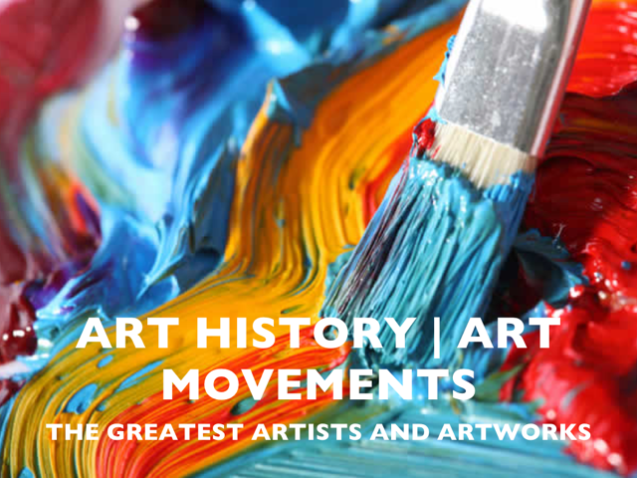

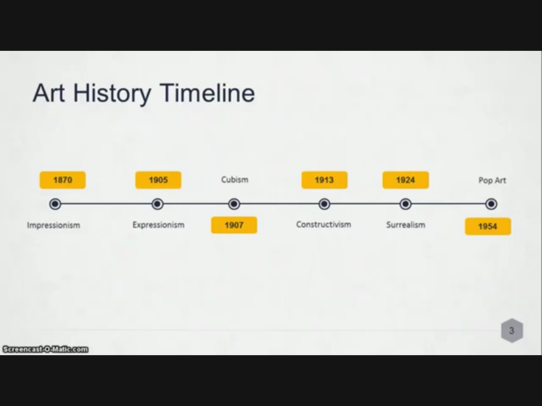

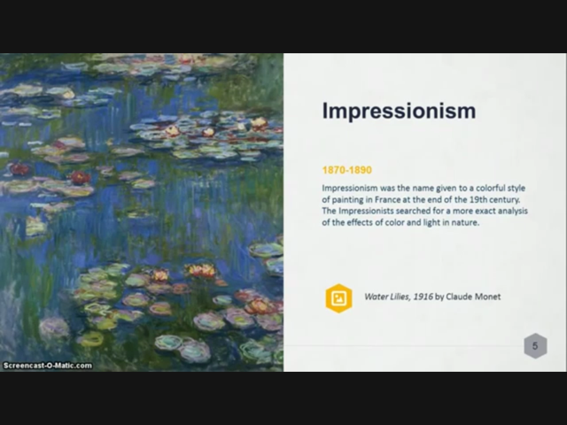

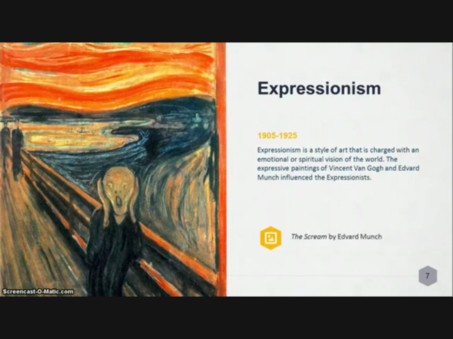

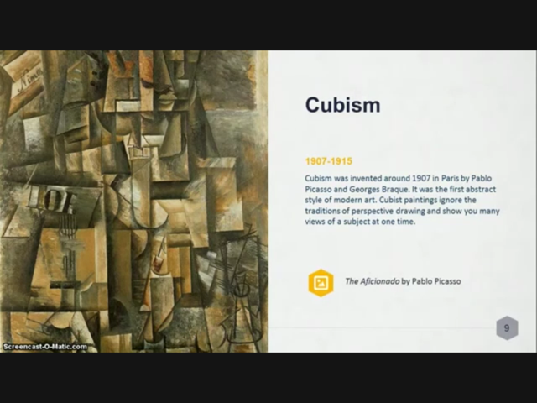

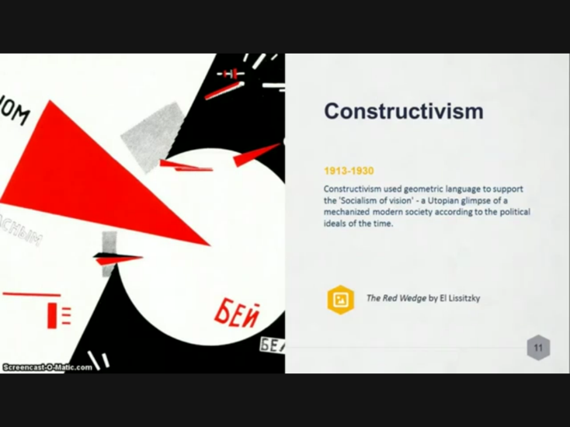

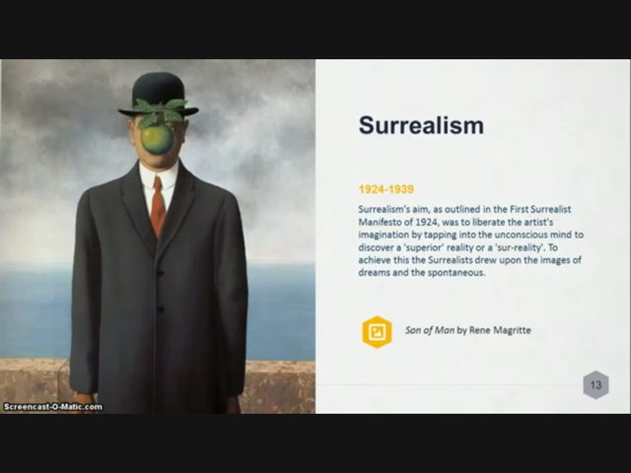

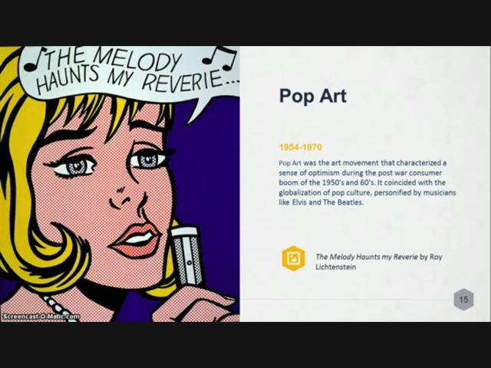

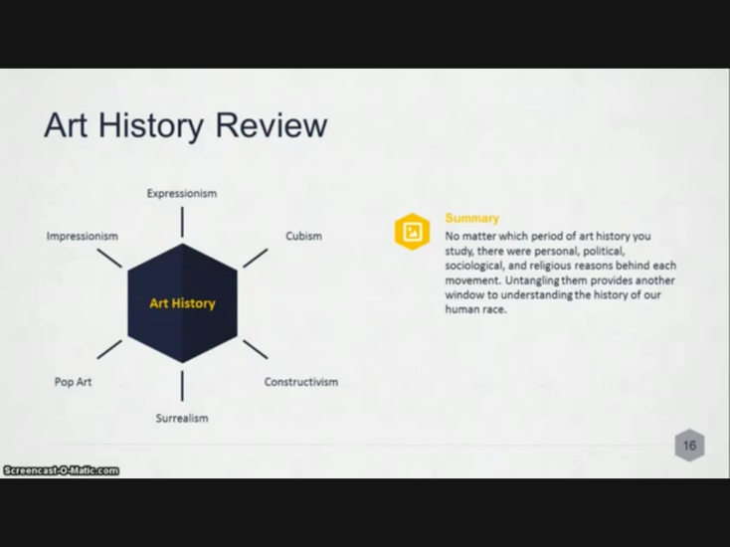

Appendix B. Group Evaluation for the Presentation of Art Movements

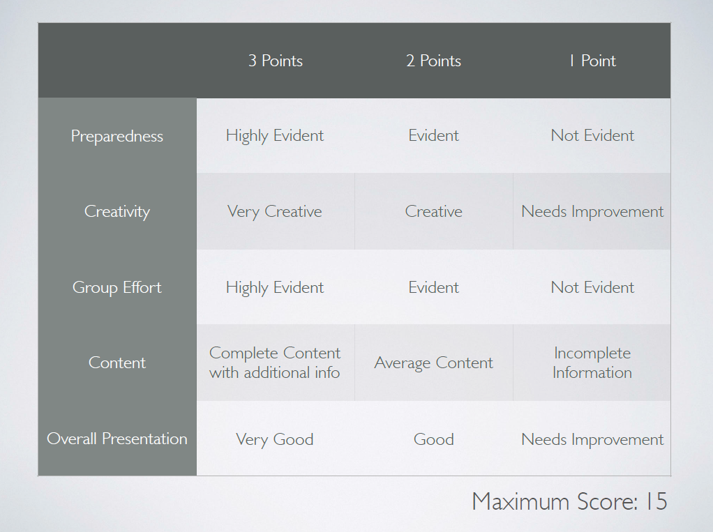

Appendix C. Rate by Pair Rubric (Poster)
 | Excellent (9 to 10 points)  Meets and exceeds the requirements and expectations | Good (6 to 8 Points)  Meets the requirements and expectations | Needs further Improvement (5 Points and lower)  Meets a few or none of the requirements given
Poster Attributes:
The poster uses more than three colors; The poster is neat; The writing/font is easy to read.
Quality of Information:
The Poster incorporates Art Styles of Artists variety of Social, Historical and Cultural Contexts.
Communication:
Use of visual tool and images communicate ideas (social purposes)

