LASALLIAN LEARNING MODULE
Teacher: Ms. Rikka Marie S. Gonzalez | Year/Level: Grade 07 |  | Subject: Art
Term Module: 01 | Title: Visual Elements and Design Principles |  | Time Frame: June - September
CONTENT STANDARD |  | PERFORMANCE STANDARD
The students demonstrate understanding that visual elements and design principles even when applied repeatedly can be used to organize visual thoughts and communication.  Elements and principles of design; techniques; composition; pattern (repetition); freehand drawing; recycling materials |  | The students will:  - Brainstorm and design a repeating visual element that can be integrated for the color scramble  - Develop final design for color scramble  - Construct a color scramble for emotionally-challenge children from the Haven for Children Foundation
RELATED LASALLIAN GUIDING PRINCIPLES
Lasallian educational experiences are dynamic processes that:
- Challenge pupils to realize their full potential by encouraging them to exercise their creativity for the good of all, especially for those who needs more motivation;
- Bring Christian perspectives to bear on human understanding skills and values of the pupils by engaging them to address inspirational concerns of the emotionally-challenged children;
- Are vigorous and encourage differentiation, diversity and synergy amongst others that are friendly, caring and respectful by encouraging them to share their constructive criticism on various ideas for a color scramble that would promote visual thoughts and communication that could potentially inspire other people to see beauty beyond repeating design;
- Ensure that students translate knowledge into something useful in actual practice for the betterment of society and the Church by sharpening their sensitivity toward the needs of the environment by creatively utilizing visual elements and design principles on a color scramble
CONTENT and COMPETENCIES
Module 01 focuses mainly on art elements, design principles, techniques, compositional planning and aesthetic expression of art forms. It strengthens prior knowledge of applied design and hone skills while affirming and deepening further the understanding of several art principles and themes related to human art form and the goodness of God’s creations.
This learning area shall include exploratory and experiential activities that will enable the students to refine their design skills and create a project which shall inculcate planned manipulation of recycled materials; to create a color scramble which would inspire children from Haven for Children Foundation to see beauty beyond their environment. Skills to enhance: Freehand drawing, design skills, proper handling and use of recyclable materials and other art materials and tools, art vocabulary and integration of visual, spatial and temporal concepts to communicate intended meaning in their artworks.

REFERENCES/ SOURCES
Bibliography

Hetland, Lois. et.al. Studio Thinking: The real benefits of visual arts education. 2007, Teachers College Press.

Percy Principles of Art and Composition (http://www.goshen.edu/art/ed/percy1.html), Goshen College Art Department.

Davidson, Rosemary. What is Art? Oxford. Oxford University Press. 1993

Holohan, Clodagh, et., al. Art, Craft and Design. Dublin, Gill and Macmillan, 1993.

Webliography

http://www.d-zignsinc.com/pantone.html

http://wapedia.mobi/en/CIE_1931_color_space.html

www.youtube.com/watch?v=x0-qoXOCOow

BLENDED TOOLS
Face-to-Face |  | eLearning
Examples:  Group/ pair discussions  Lab works  Games  Coaching  Reflective Study |  | Examples:  Web research  Wiki interaction  Virtual classroom  Simulations  Online forums  Use of apps (e.g., productivity, assessment, presentation)

STAGE 1: ESTABLISHING DESIRED RESULTS
TRANSFER GOAL(S): (from Unpacking the Standards)
Students will independently use their learning to:
- find meaning and interest in varied works and performances of art;
- create a work of art to evoke mood and emotion through application of proper art media and technique;
- evaluate a work or performance to determine its value; and
- create a portfolio of accomplishments documenting experience to promote themselves as developing artists.

BIG IDEA/ENDURING UNDERSTANDING (EU):

EU:
- Students will understand that art elements and design principles can be used to organize visual communication and can be used intentionally to elicit a specific response from the viewer.
- Students will understand that the combination of colors affect people somehow.
- Students will understand that the repetition of a single unit creates a pattern much more beautiful than the original unit (gestalt principle of “the whole being greater than the sum of its parts)
ESSENTIAL QUESTION(S):

EQ:
- How are art elements and design principles used to organize and express ideas?
- How are art elements and design principles used to organize and express ideas?
- Why is it important to study color combination?
- What is the gestalt principle in relation to Art?

STAGE 2: DETERMINING VALID EVIDENCE/ASSESSMENT
PRODUCT OR PERFORMANCE SHOWING EVIDENCE OF UNDERSTANDING IN GRASPS FORMAT
The students are artistic product developers (R) engaged in a creative product analysis meeting of developing artists, called upon by an Art Organization – The Institute of Healing Arts and Films, to discuss and create and/or innovate an artwork that could (S) potentially meet the needs of emotionally-challenged children at the (A) Haven for Children Foundation.
The class will be divided into pairs to work on (G) creating a color scramble and each pair shall be asked to propose a (P) non-biodegradable material which will be used for the construction of the project upon approval of the final design.
Upon the completion of the project, (S) a discussion of its use and importance shall be presented for constructive criticism to the Art Direction (the Teacher) and make revisions if necessary.

ASSESSMENT TOOLS (taken from your Curriculum Map)
 | Knowledge  F: Recognize visual elements and principles observed in artworks or the environment. | Process  F: Visually recognize and interpret visual elements and principles used and integrated in various art forms. | Understanding  F: Synthesize orally the fundamental visual and emotive nature of what has been observed in the environment that can be used to represent visual expression. | Performance/ Product  S: Rubric for Color Scramble evaluated by self and peer evaluations.
Pre-assessment | KWL
Formative assessment | Drawing from Observation | Journal Logs | Case Analysis  Editorial/Cartoon Analysis | Graphic organizers
Summative assessment | Assessments 1-2 | Assessments 2-4 | CUA | Scoring Rubric

RELATED FACET(S) OF UNDERSTANDING:
EXPLANATION
- Explain the importance and use of a Color Scramble.
- Identify possible impact of the Color Scramble in the lives of emotionally-challenged children.
INTERPRETATION
- Given the characteristics and parameter of the Color Scramble, interpret possible ways in which the design could potentially uplift the emotion and mood of emotionally-challenged children.
APPLICATION
- Identify visual compositions that can be integrated and applied on the design of the Color Scramble and discover non-biodegradable materials that can be applied in the construction of the project.
PERSPECTIVE
- Reflect on the impact of art in our lives.
- Appreciate individual and collective sources of creativity.
EMPATHY
- Showing mindful cooperation to integrate ideas of creative individuals through designing a color scramble.
SELF-KNOWLEDGE
- Realize how one can become an agent of change in another man’s life.

STAGE 3: LEARNING PLAN FLOW
LESSON PROPER

Day 1:

- INTRODUCTION OF ESSENTIAL QUESTIONS and TRANSFER GOAL

- The class shall be grouped into 6 groups.
- The essential question will be presented and given to each group and initial answers shall be recorded in Activity Sheet 01: How are art elements and design principles used to organize and express ideas?
- A PPT (Appendix A) will be presented to the class for the introduction of the module.

- INTERACTION (all activities after the introduction of the EQ)

Day 2-3:

- Guidelines for the group activity will be given to the students
- The students will be briefed about the Foundation which will be the beneficiary of the project
- The students will be watching a video (Children, Violence, and Trauma – A Call for Action) that can potentially help them identify ways by which they can uplift the mood and emotions of emotionally-challenged children
- By pair, the students should create a draft for a proposed design for the color scramble
- The pair shall think of non-biodegradable materials that can be used for the construction of the Color Scramble

Day 4:
- Create a concept sketch for the color scramble (the final design should be approved by the Art Teacher)

Day 5-7:
- Construction of the color-scramble following the approved design by pair
- INTEGRATION
Researchers and experts have made a few important discoveries and observations about the psychology of colors and the effect it has on moods, feelings, and behaviours. It was demonstrated in many cases that the mood-altering effects of color may only be temporary but can still potentially uplift moods and emotions.

As a developing artist, you were commissioned by an Art Organization to be part of their project – that is, to create an artwork that could potentially meet the needs of emotionally challenged children at the Haven for Children Foundation.

In relation to this, you were tasked to make a color scramble that could potentially inspire the emotionally challenged children to see beauty beyond repeating designs and colors, and to help uplift their moods and emotions. This project will be submitted and approved by the Art Director.

Day 8:
- Present the color scramble to class and explain the importance and how the conceptualized design could potentially help in uplifting the emotion and mood of emotionally-challenged children
- Rate by pair the rubric (Appendix B) for Module 01

Day 9:
- Answer the essential questions
- Write a brief reflection of how the acquired knowledge can be utilized in real-life situations.

APPENDICES

Appendix A. Grade 7 Performance Task

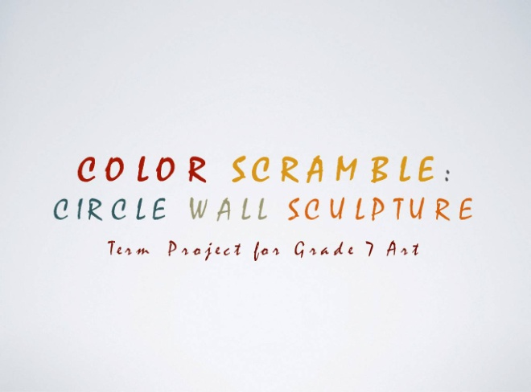

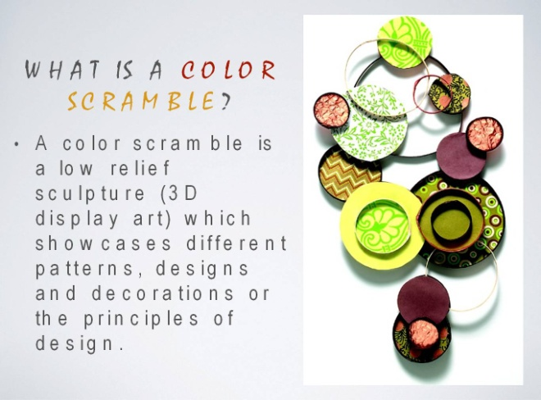

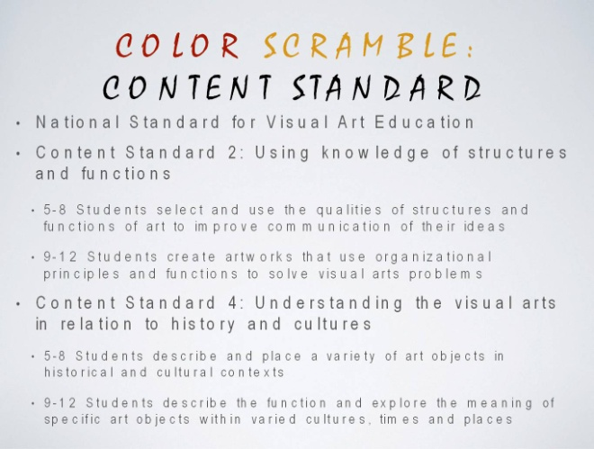

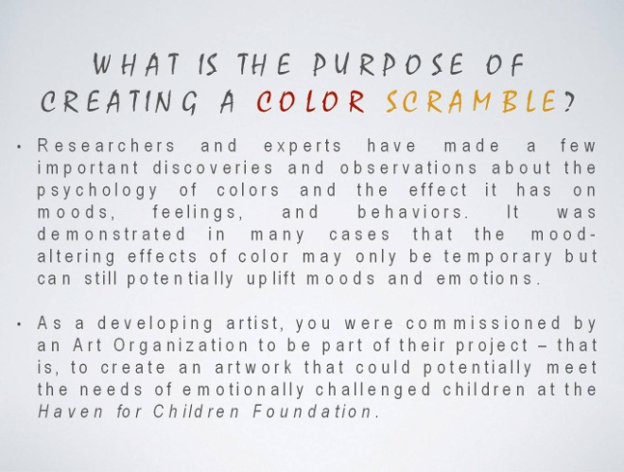

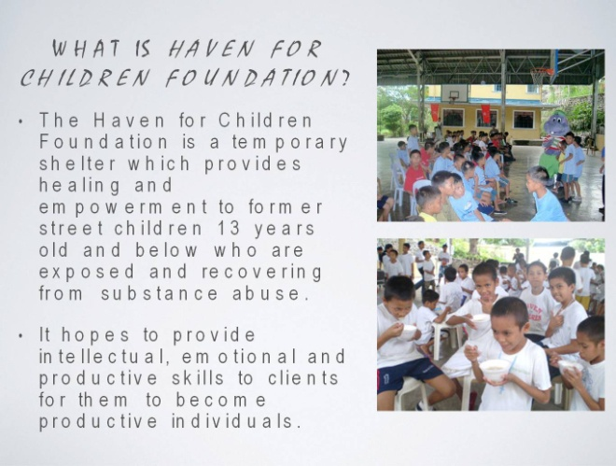

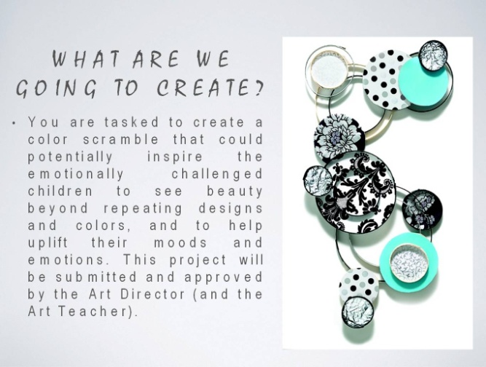

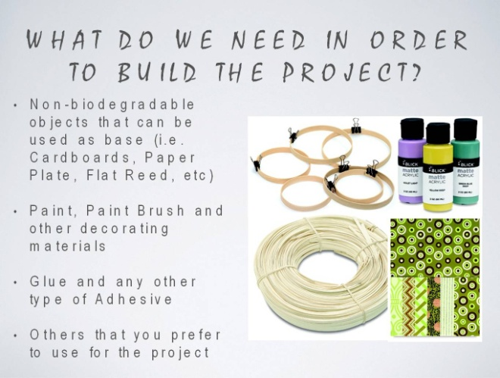

Appendix B. Rate-by-pair Rubric

